AWUTU SENYA EAST MUNICIPAL ASSEMBLY ENVIRONMENTAL HEALTH AND SANITATION UNIT



WEEKLY REPORT ON MUNICIPAL SOLID WASTE MANAGEMENT (MSWM) AND PUBLIC CLEANSING AT KASOA CENTRAL
BUSINESS DISTRICT AND NEW MARKET FOR THE PERIOD OF JULY 7TH TO 13TH JULY 2025

JULY,2025

SUBMISSION OF WEEKLY MUNICIPAL SOLID WASTE MANAGEMENT AND PUBLIC CLEANSIMG REPORT

I submit as per attached weekly report on Municipal Solid Waste Management and Public Cleansing at Kasoa Central Business District and New Market for the period 7th to 14th July, 2025 for your consideration and implementation of recommendations therein.

Thank You

HON. MUNICIPAL CHIEF EXECUTIVE GODSON M. LODO
AWUTU SENYA EAST MUNICIPAL ASSEMBLY
KASOA

WEEKLY REPORT ON MUNICIPAL SOLID WASTE MANAGEMENT (MSWM) AND PUBLIC CLEANSING AT KASOA CENTRAL
BUSINSS DISTRICT AND NEW MARKET FOR THE PERIOD OF JULY 7TH TO 13TH JULY, 2025

1.0 BACKGROUND INFORMATION ABOUT AWUTU SENYA EAST MUNICIPAL
The Awutu Senya East Municipal (ASEM) was carved out of the erstwhile Awutu Senya District in 2012 in pursuance of the government`s decentralization and local government reform policy as enshrined in the L I 2025 with its capital at Kasoa.
ASEM is situated between Latitudes 5˚20’N and 5˚and Longitudes 0⁰25’W and 0⁰37N at the eastern part of Central Region of Ghana. It shares borders with the Ga South Municipal in the Greater Accra Region to the east, Awutu Senya District and the Gulf of Guinea to the south and the Gomoa East separating the south of the municipal from the inland.
The Municipal has six (6) Sub- Municipal structures which are all Zonal Councils (ZC). These are Adam Nana ZC, Iron City ZC, Opeikuma ZC, Ofaakor ZC and Kaemebre/Akweley ZC. (Appendix 1 Refers)
The municipal covers an area of 108.004 square kilometers. It currently has a population of about 250, 000 living in 72 settlements. (Appendix 2 Refers)

2.0 MUNICIPAL SOLID WASTE MANAGEMENT AND PUBLIC CLEANSING AT THE CBD AND NEW MARKET
With the current population of about 250,000, ASEM generates an estimated average household solid waste of 125 tons a day given per capita solid waste generation of 0.5kg. Owing to the high transit population coupled with the numerous commercial activities taking place in the municipality, ASEM generates averagely about 30 tons of commercial solid waste a day making an average total weekly solid waste generation of 210 tons of which close to190 tons accounting for 90% is collected and safely disposed off on weekly basis.
Currently, nine (9) accredited private municipal solid waste collection service providers whose service delivery according to most of their clients is not satisfactory, the Assembly and the informal sector which is made up of 315 private Aboboyaa tricycles and KIA tipper trucks are involved in municipal solid waste collection in the municipality.
Due to improper regulation of these service providers and weak enforcement of the Assembly’s Environmental Health and Sanitation Bye Laws by the Assembly, Municipal Solid Waste is visibly dumped at the Kasoa Central Business District (CBD) , the New Market and public drains leads to aesthetic problems, flooding and upsurge of sanitation related diseases such as Typhoid fever, Dysentery, Cholera, etc. which accounts for 20% of total number of diseases recorded in the Municipality yearly.
As a result of the numerous heaps of MSW openly dumped and seen around the Kasoa New Market and CBD enclaves on daily basis, the Environmental Health and Sanitation Unit of the Assembly which owns it as a responsibility to educate the populace and enforce the Assembly’s Sanitation bye laws are not motivated, do not have the moral justification and do not have means of transport to embark on their outreach activities as expected.
2.1 MUNICIPAL SOLID WASTE MANAGEMENT AND PUBLIC CLEANSING ACTIVITIES UNDERTAKEN DURING THE PERIOD UNDER REVIEW
Activities undertaken by the unit during the period under review included;
- Supervision of sweeping and collection of waste at the CBD by Zoomlion Ghana Limited operatives and five casual labourers of the Assembly

- Supervision of sweeping and collection of waste at the new market by both Assembly casual labourers and Mr. Emmanuel Dosoo’s Private Service Providers

- Supervision of haulage and safe disposal of waste at the New Final Disposal Site located at Bentum by both Zoomlion Ghana Limited and a hired private refuse compaction truck

- 2.2 QUANTITY OF MUNICIPAL SOLID WASTE COLLECTED AND SAFELY DISPOSED OFF DURING THE PERIOD UNDER REVIEW BY THE SERVICE PROVIDERS
S/NO | SERVICE PROVIDERS | COLLECTION LOCATION | QUANTITY OF MSW SAFELY DISPOSED OFF
 | Zoomlion Ghana Limited | Kasoa CBD | 94.5 Metric Tons
 | Hired private compaction truck | Kasoa New Market | 94.5 Metric Tons
Total quantity |  |  | 189 Metric Tons

2.3 FUNDING OF MSWM FOR THE PERIOD
ESTIMATED AMOUNT GH₵ | AMOUNT APPROVED GH₵ | SOURCE OF FUNDING
11,283.50 | 10,719 | DACF

3. 0 RELATED PICTURES OF THE SCENE
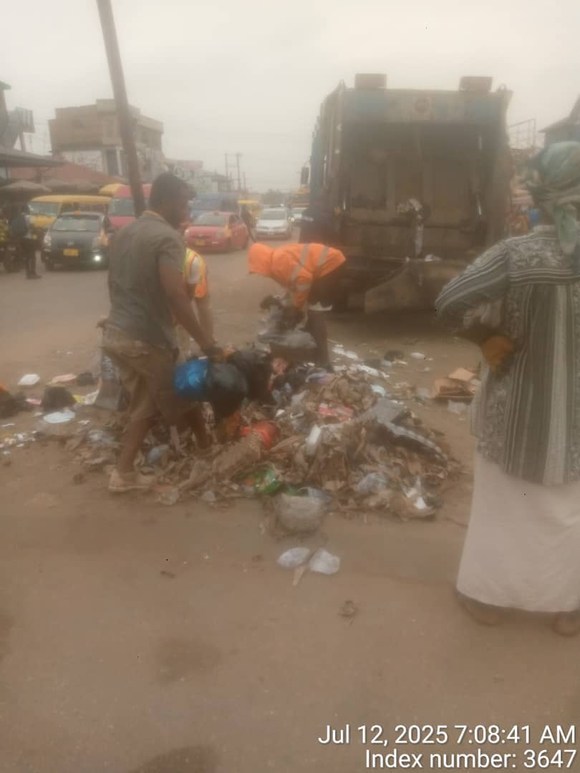
Sweeping and Collection Of MSW ongoing at Kasoa CBD by five casual labourers of the Assembly and Zoomlion Ghana Limited Operatives
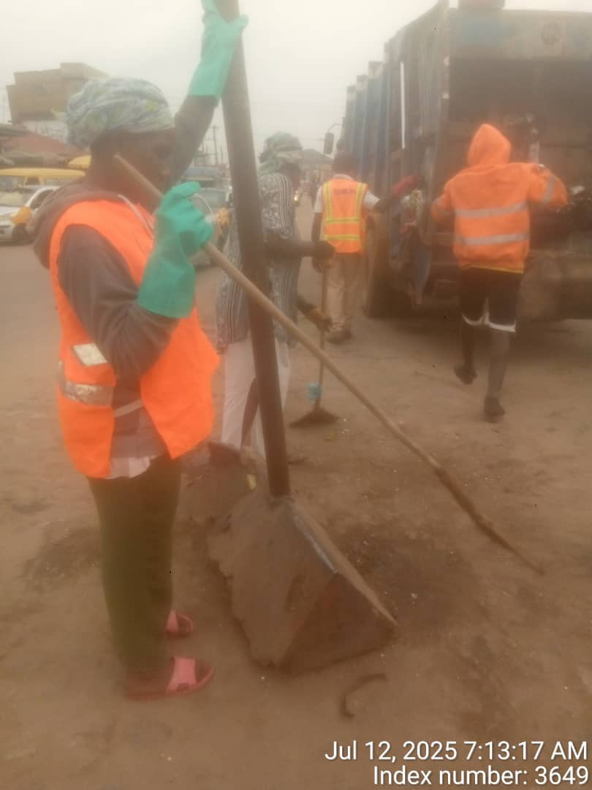
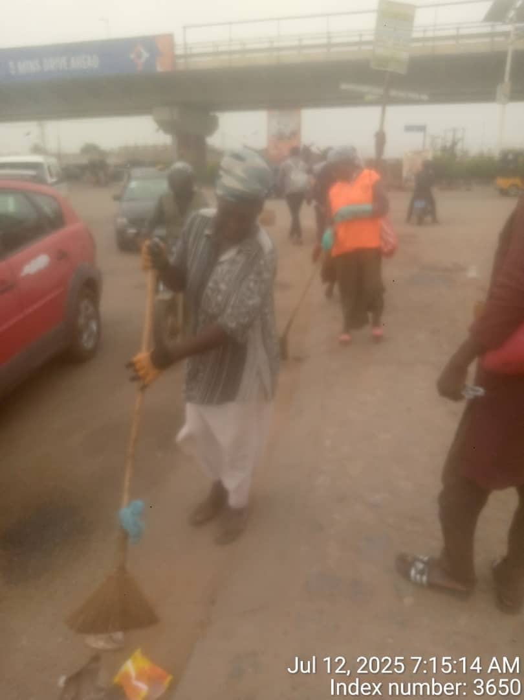
Sweeping and collection of MSW ongoing at Kasoa CBD by five casual labourers of the Assembly and Zoomlion Ghana Limited Operatives
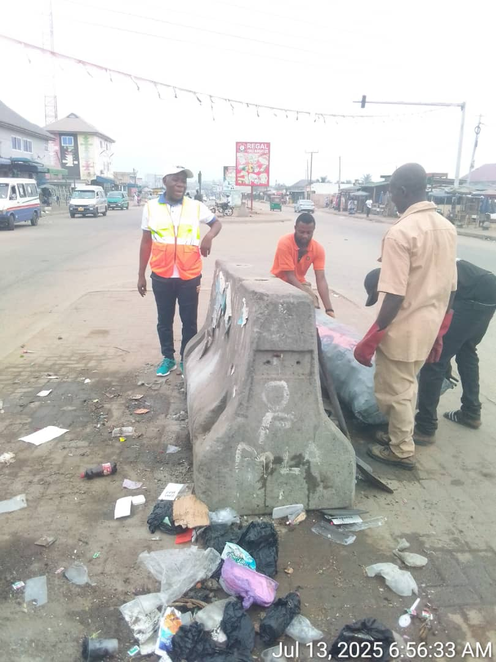The Municipal Environmental Health Officer, Mr Godson M. Lodo supervising Zoomlion operatives at Kasoa CBD
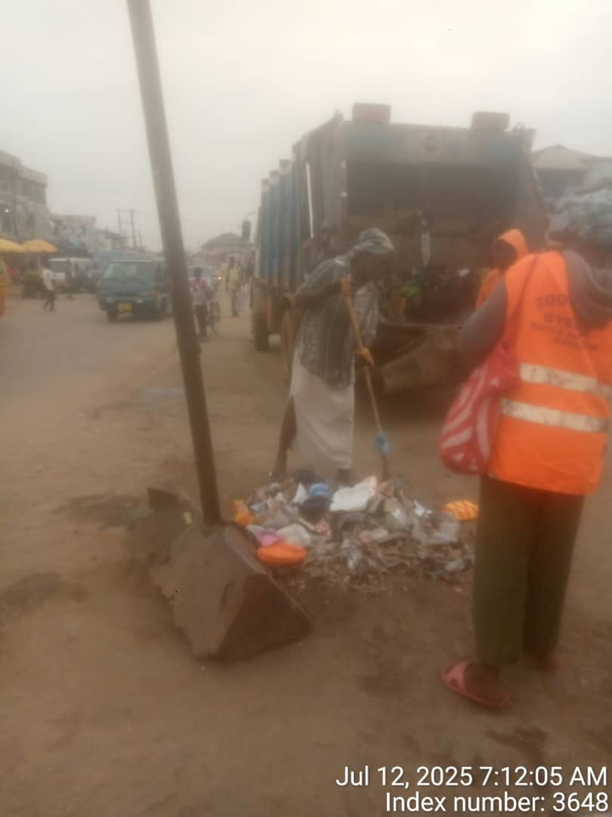
Sweeping and Collection Of MSW ongoing at Kasoa CBD by five casual labourers of the Assembly and Zoomlion Ghana Limited Operatives

4.0 CHALLENGES AND RECOMMENDATIONS
S/No. | CHALLENGES | RECOMMENDATIONS
1. | Indiscipline among the populace resulting in indiscriminate littering and dumping of waste openly at Kasoa CBD and New Market. | Intensification of public education on good waste disposal practices and arrest and prosecution or imposition of on the spot fine on offenders.
2. | Lack of working tools such as brooms, baskets hand gloves and filter masks to enhance sweeping and collection of waste. | We need to get working tools and PPEs for the labourers to enhance their work.
3. | The 5 casual labourers still use ZoomLion Ghana Ltd. Reflective vests. | We recommend provision of reflective vests embossed with ASEMA and ASEMA Logo to enhance visibility of the labourers during work.
4. | Lack of refuse truck to collect and haul waste from the New Market by the Assembly. | Assembly should acquire it’s own refuse truck, preferably a skip refuse truck to collect and haul waste from the New Market instead of depending on a hired tipper truck.

Submitted for your consideration and implementation of aforementioned recommendations.

Report Compiled and Approved By

GODSON M. LODO
(MUNI. ENVIRONMENTAL HEALTH OFFICER)

